**YEAR 11 ATAR CHEMISTRY – Unit 1**

**TEST 2 ANSWERS**

**Atomic Structure and Bonding**

**Recommended time: 60 minutes**

Name: ___________________________________________________

|  |  |
| --- | --- |
|  | Total Marks |
| Part 1 & 2 | /40 |
| Part 3 | /10 |

Teacher: __________________________________________________

This test is in two parts.

**Part 1:** MULTIPLE CHOICE style test consisting of FIFTEEN (15) questions.

Each question is worth one mark.

Write your answers in the Multiple Choice Answer Sheet.

Attempt ALL Questions

**Part 2:** SHORT ANSWER questions worth a total of 25 marks.

Write all answers in the spaces provided on this sheet.

The marks allocated to each question are shown.

Attempt ALL Questions

**Part 3:** EXTENDED RESPONSE one question worth a total of 10 marks.

Write all answers in the spaces provided on this sheet.

MULTIPLE-CHOICE ANSWER SHEET

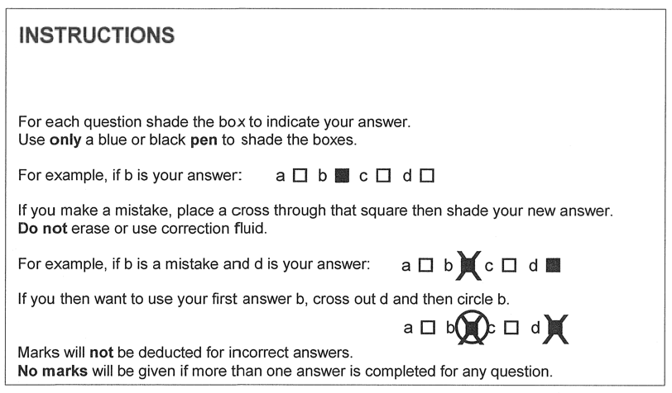

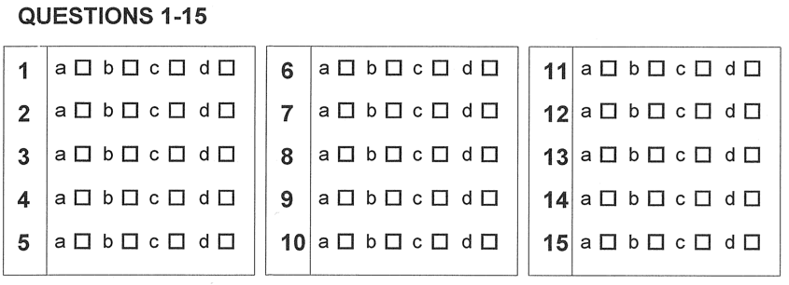

PART ONE: MULTIPLE CHOICE (15 marks)

*Answer the questions by marking the corresponding letter of your selected answer on the answer sheet provided. Each question in this section is worth 1 mark.*

________________________________________________________________________

1. Which of the following species does **not** have the same electron configuration as the others?
   1. Na+
   2. Ca2+
   3. Ne
   4. O2-
2. An unknown element, X, reacts with chlorine to form an ionic compound having the formula XCl3. If the ion of X has 21 electrons, identify the element;
   1. Cr
   2. Sc
   3. Co
   4. Mn
3. The species that has 10 electrons, 8 protons and 10 neutrons is;
   1. an oxygen ion
   2. an argon atom
   3. a neon atom
   4. a fluorine isotope
4. Which one of the following will **not** conduct electricity?
   1. Molten sodium hydroxide
   2. Molten sulfur
   3. Liquid mercury
   4. Solid graphite
5. Which one of the following compounds contains both ionic and covalent bonds?
   1. MgF2
   2. CH3Cl
   3. NaNO3
   4. CH3NH2
6. An atom has the following electron configuration;

2,8,7 that can be written as 1s2 2s22p6 3s23p5

Which of the following statements regarding this atom are true?

I The substance is an alkali metal

II The substance is in the 3rd period

III The substance would form an ion with a -1 charge

IV The substance is a halogen

V The substance is in group 15

1. I and III
2. II and V
3. III and IV
4. II, III and IV
5. The element magnesium, Mg, has an atomic mass of 24.32 and an atomic number 12. It has three naturally occurring isotopes, with mass numbers 24, 25 and 26. Which of the following statements about magnesium is incorrect?
   1. All atoms of magnesium have the same number of electrons
   2. All atoms of magnesium have 12 protons
   3. The three isotopes of magnesium have similar properties
   4. All atoms of magnesium have identical nuclei
6. The species which have an electron configuration similar to those of noble gases are:

a. Ne, C, Cl, F

b. B+, Na+, O2-, F-

c. S2-, N3-, Mg2+, Li+

d. Xe-, Kr+, Al3+, H+

9. What is the atomic mass of a hypothetical element consisting of two isotopes, one with mass = 64.23 amu (26.0%), and one with mass = 65.32 amu?

a. 65.3 amu

b. 64.4 amu

c. 64.9 amu

d. 65.0 amu

10. Which of the following is **not** a step in atomic absorption spectroscopy (AAS)

a. Atoms absorb light.

b. A solution is vapourised.

c. A Calibration curve is constructed.

d. Particles are adsorbed onto a stationary phase.

11. With regard to the species 16O2-, 19F1- and 20Ne, which of the following statements is correct?

a. All three species contain 10 electrons.

b. The sum of the neutrons in all three species is 27.

c. The sum of the protons in all three species is 28.

d. Both 19F1- and 20Ne contain 20 neutrons.

12. Which of the following elements has atoms with the greatest ability to attract electrons?

a. silicon

b. sulfur

c. magnesium

d. chlorine

13. Acceleration of ions through an electric field occurs in:

1. mass spectrometry.
2. emission spectroscopy.
3. atomic absorption spectroscopy.
4. flame test

14. Carbon dioxide has a low melting point because:

1. the forces between the carbon and oxygen atoms are weak.
2. it is an ionic substance.
3. the atoms share electrons.
4. the forces between the molecules are weak.

15. In which of the following solids would you expect to find discrete

molecules?

1. sulfur
2. sodium cyanide
3. aluminium
4. graphite

PART TWO: SHORT RESPONSE (25 marks)

________________________________________________________________________

1.

|  |  |
| --- | --- |
| protons | 16 |
| neutrons | 17 |
| electrons | 16 |

a.

1 mark for all three correct

½ mark for two correct

0 marks for 1 correct

b. 2,8,6 or 1s22s22p63s23p4 1 mark

c. 2,8,8 or 1s22s22p63s23p6 1 mark

(3 marks)

2.

a. B&D or E&H 1 mark

1. B or C 1 mark
2. BDEHF with GC 1 mark
3. answer D 1 mark

explanation  
Element D has one more energy level (1 mark) increasing the distance between the nucleus and outer most electrons (1 mark).

(6 marks)

3. Half mark per answer

|  |  |  |  |
| --- | --- | --- | --- |
|  | Symbol | Name | Bonding type |
| a) |  | Aluminium phosphate | Ionic |
| b) |  | Magnesium | metallic |
| c) |  | Carbon tetrachloride | Covalent molecular |
| d) |  | Nitrogen dioxide | Covalent molecular |
| e) |  | Fluorine | Covalent molecular |
| f) |  | Sodium oxide | Ionic |

1. marks)

4. 1 mark per diagram, -1/2 mark no non bonding electrons

|  |  |  |
| --- | --- | --- |
|  | Species | Electron Dot Diagram |
| a) |  |  |
| b) |  |  |
| c) |  | 2[Al]3+ 3[ S ]2- |

(3 marks)

|  |  |
| --- | --- |
| Sodium chloride is ionic. An ionic substance comprises alternate positive and negative ions in its crystal lattice. (1/2 mark)  If a (shear) force applied to a particular layer in the crystal lattice aligns ions with similar charge, the repulsive force between them disrupts the ionic bond. (1 mark)  Sodium is metallic. In metals, positive metal ions are surrounded by delocalised, mobile electrons. (1/2 mark)  When a force is applied, the positive nuclei are able to slide to a new position as the electrons stop the repulsion between nuclei and the new arrangement resembles the original. (1 mark)    Diagrams ½ mark per diagram | |
| [http://www.bbc.co.uk/staticarchive/fba2965c626a450042effd6174b49257d3b3a69f.gif](http://www.google.com.au/url?sa=i&rct=j&q=&esrc=s&source=images&cd=&cad=rja&uact=8&ved=0ahUKEwjqvPbIoMfLAhVFNJQKHZeWDV8QjRwIBw&url=http://www.bbc.co.uk/schools/gcsebitesize/science/add_aqa_pre_2011/atomic/differentsubrev5.shtml&psig=AFQjCNHi3pVDtjqQAWfMBRDhAN5YbGxH8Q&ust=1458288055914633) | Ionic lattice of sodium chloride, showing positively charged sodium ions bonded to negatively charged chloride ions  Ionic |

1. Explanation
2. marks)
3. Carbon dioxide is a covalent molecular substance while silicon dioxide is a covalent network substance (1 mark). Carbon dioxide exists as discrete molecules with weak intermolecular forces (1/2 mark). Not a lot of energy is required to disrupts these forces (1/2 mark). Silicon dioxide is a 3D structure of repeating strong covalent bonds (1/2 mark). A lot of energy is required to break these bonds (1/2 mark).

(3 marks)

PART THREE: EXTENDED RESPONSE (10 marks)

________________________________________________________________________

Max 5 marks per scientist

Rutherford

Experiment 2 marks

1 – Beam of alpha particles targeted at a thin sheet of gold foil

1 – Some alpha particles were deflected

Contribution to model 2 marks

1 – Atoms consist mostly of empty space

1 – Most of the atoms mass is located in the nucleus that is positively charged

Diagram

1 –

Thomson

Experiment 2 marks

1. Use of cathode ray tube, charged metal plates and a magnetic field
2. to determine the charge to mass ratio of electrons and estimate their mass.

Contribution to model 2 marks

1. Atoms consist of numerous very small, negatively charged electrons
2. Embedded in a larger uniformly charged positive sphere

Diagram